LAB 1
COURSE: COMPUTER NETWORK

CREATING A WEBSITE AND

CONFIGURING A WEBSERVER

Objective
- Student can create a simple webpage with HTML
- Student can install and configure the webserver to publish a website.

Requirements
- Students work in group of 2.

Creating a simple website
- Open a text editor: Notepad, Notepad++
- Typing the following HTML code:
<!DOCTYPE html>
<html>
<head>
<title>Computer Network lab - 2</title>
</head>
<body>
<h1>StudentID 1: FullName</h1><br>
<h2>Class: </h2><br>
<h1>StudentID 2: FullName</h1><br>
<h2>Class: </h2><br>
</body>
</html>
Student can study HTML in following website:
- http://www.w3schools.com/
- https://www.codecademy.com/tracks/web
Student can add image, audio, video into the website.
- Save the website into a folder with the name MSSV.html (MSSV is the student ID). Note that, the website should be save in the Disk D, or E (not in C)

Configure Webserver with IIS on Windows
- Turn on the IIS serviceon Windows: Control Panel -> Programs and features -> Turn Windows Features on or off -> choose Internet Information Service -> OK
- Test the active service by typing the URL http://localhost, in a web browser, a default website should appear.
- Search Internet Information Services (IIS) Manager to configure the web service.
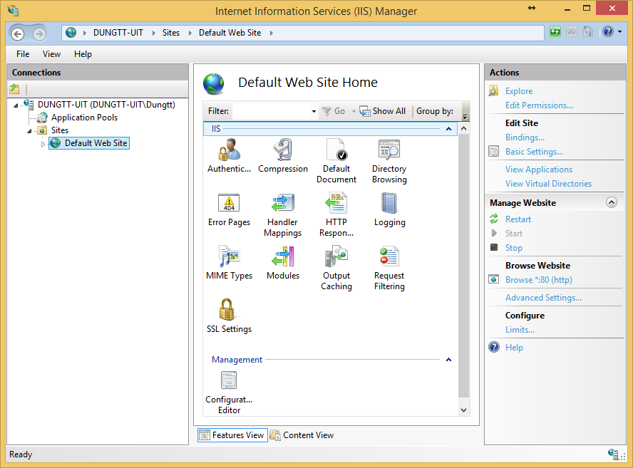

- Click on Stop to stop the default Web Site
- To create new Website, right click on Site -> Add Website. Name the Sitename as MSSV (Student ID), Physical path is the path to the MSSV.html file in part 1.
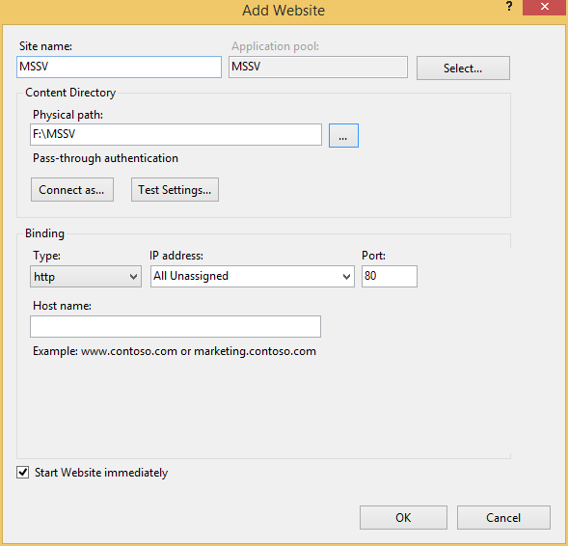

- Access the link http://localhost/MSSV.html
- Access your partner’s with the link A.B.C.D/MSSV.html with A.B.C.D is the IP of your partner’s computer. MSSV.html is your partner’s file.
Note: Show the IP address:
- Windows+R to open Run
- Type cmd -> OK
- Type ipconfig to show the IP of a computer

Capture HTTP packet and get Basic HTTP GET/response interaction
- Open web browser, clear cache
- Open Wireshark and type “http” into display-filter window to get the HTTP message.
- Start capture.
- Access the partner’s website.
- Save the capture with the name MSSV.pcap.
Open the MSSV.pcap, type “http” into display-filter window to get the HTTP message and answer the following questions:
- Find the HTTP request and the HTTP response of the communication and summarize the information from the request and the response (capture the corresponding figure).

